FleetCom

Design Document

VERSION 1.0.0

05 Sep 2013

# Index

Contents

Index 2

Game Overview 4

What is this Game About? 4

Game Details 4

Description 4

Game Genre 5

Single Player or Multiplayer 5

2D or 3D 5

Setting 5

Controls, Characters and Vehicles 5

Main Focus 5

Game Length 5

Comparison 5

What is Unique 6

Why Create This Game 6

Reviews 6

Game Reviews 6

Player Comments 6

Business 6

Competitive Strategies 6

3 Reasons People Would Buy this Game 6

Business Model 6

Feature Set 6

General Features 6

Multiplayer Features 6

Gameplay 6

The Game World 9

Overview 9

Key Locations 9

Travel 10

Scale 10

Weather 10

Camera 10

Overview 10

Game Characters 10

Overview 10

Character Creation 11

Enemies 11

User Interface 12

Overview 12

Game States 13

Main Menu 14

Achievements 14

Base Review 15

Incursion Map 15

Star Cluster Map 15

Base Configuration Screen 15

Research 16

In Game 16

Pause 16

Debriefing 16

Game Over 16

# Game Overview

## What is this Game About?

This game was born out of a drawing I’d make in high school depicting ships from many different game, TV, and movie universes all battling each other. In an attempt to make it a reality, this game will utilize ships from many different media genres, under fake aliases, to see that become reality.

The user will take the spot of a commander of a fleet in a universe where the fabric of spacetime has thinned and frayed, allowing a bleed through effect. The player undertakes a mission where they must assume command of the naval forces of Earth in order to eliminate the threat to Earth and her colonies, and repair the region of space that has become weakened in order to prevent any further ships from coming through.

# Game Details

## Description

Periodically, ships from another reality will show up. The player will take direct command of a vessel of their choosing that they already own, in a minigame where they must destroy the commander of the opposing fleet. Upon successful completion, the user will gain the ability to build ships from the enemy’s fleet.

At the beginning of every battle, the user will have the option to build one of many ships their fleetyards are capable of producing. The number of ships the fleetyard is capable of producing is dependent upon the production capacity. That can be increased when the fleetyard is attacked. In another minigame, the player will take control of a fighter, and must use it to root out and eliminate enemy fighters.

While selecting their ships, the player will be able to see a preliminary intel report of the enemy forces (how many ships of what class the enemy has sent). Many ships are carriers, and contain a number of fighters and/or other ships inside of them. These smaller ships will be automatically deployed with the carrier, and they will be rebuilt at the carrier during battle.

During battle, the player will draw lines from their ships to enemy ships in order to set target priority. Otherwise, ships will simply target the closest enemy.

The player will gain resources for every ship destroyed, and gain bonuses for destroying ships quickly (using the right kind of ships against enemy ships). Ships will not have a 100% accuracy rate, and accuracy will drop depending on the ship’s weapon/target type (a battleship’s main gun will have next-to-no accuracy against a fighter).

At any point, the player may initiate research to upgrade a weapon, armor, shield, or engine type. Each research item will have a cost, and take a number of actions to complete (each battle counts as an action).

The player may pay a cost to equip their fleetyards with automated defenses.

The player may only have up to 3 different race’s ships at any given time. Natural affinity bonus is given for using Earth ships from other realities.

If a player’s fleet is destroyed, the remaining enemy forces will head for Earth and engage her defensive fleet. When that fleet is depleted, the player loses the game

## Game Genre

The main game will be a side-scrolling arcade fighter, with many strategy elements.

## Single Player or Multiplayer

The main story will be single player, with a multiplayer component where players can pit their fleets against each other.

## 2D or 3D

The game will rely on simple 2D graphics.

## Setting

The game takes place in a parallel universe. Here, the fabric of spacetime in a region a few systems away from Earth was malformed during the big bang, resulting in a thin veil between this reality, and several parallel ones. Ships from parallel universes sometime accidentally fall through, and sometimes the more aggressive neighbours send fleets through to destroy and conquer. Earth in this period has developed several dozen extrasolar colonies before discovering this region of space, and has a sizeable military force used for Earth defense.

## Controls, Characters and Vehicles

The player controls their flagship during combat, and commands the collective ship production capacity of the Empire.

The player controls the single character of the Admiral of Earth’s navy.

The game takes place in ships.

## Main Focus

The main focus of this game lies in resource management and controlling the production of the fleetyards of Earth.

## Game Length

Individual matches last anywhere from 15 seconds to several minutes, depending on the severity of the attack, or if it’s a defense mission. The main game itself will last for several hours as the player progresses through the enemy fleets.

## Comparison

* StarCraft
  + Takes place on ground, no minigames for taking direct control of units
* Sins of a Solar Empire
  + Limited to 3 races, no minigames
* Any Flying Fighter Sim
  + Limited to 1 ship/plane, usually with no backup, and no control of the larger picture

## What is Unique

No game really combines the strategic fleet management with being able to take direct control over the ships you produce. As well, no game has the unique setting this one does.

## Why Create This Game

Because it’s fun and I want to.

# Reviews

## Game Reviews

## Player Comments

# Business

## Competitive Strategies

* Sins of a Solar Empire
  + Price
* StarCraft
  + Price
* Other Indie Games
  + Wide marketing, Steam Greenlight and Windows 8 Store

## 3 Reasons People Would Buy this Game

* Because people want to see ships from their favorite franchises fight against each other in a balanced, controlled environment
* It satisfies that OCD itch to micromanage and control
* It’s cheap!

## Business Model

People will buy the base game, which will include a number of playable races, and unlocks for more advanced ships and races.

DLC will be available for extra races as I make them.

# Feature Set

## General Features

The ability to create your fleets and research ships and advancements, and pit them against enemies from other series/genres.

Minigames to defend your fleetyards and bases from enemy attacks.

## Multiplayer Features

Proximity multiplayer matches.

## Gameplay

* The player will start off with a small fleet of very basic ships
* An initial fund will be provided
* Attacks on bases and fleetyards will happen
  + Player will take a flagship and go and battle the enemy
* Research may be taken multiple times, each time slightly increasing the number modifier
* Research to enhance
  + Weapon Types
    - Rate of Fire
    - Damage
    - Accuracy
    - Additional Effects based off of type
      * Explosive
      * Shield-Draining
      * Anti-armour
      * EMP (Slowing)
  + Hull and Ship Structure
    - Armor types
    - Hull configuration
    - Strong points
    - Damage control
    - Advanced compartmentalization (?)
    - Emergency shields
    - Redundant bulkheads
    - Hull layering
  + Shields
    - Rotating frequencies
    - Advanced harmonics
    - Multiple emitters
    - Overlapping emitter fields
    - Rapid cycling
    - Capacitors
  + Engines
    - More Thrusters
    - Increased Thruster Efficiency
    - Exhaust Constriction
    - Afterburners
    - Decreased warmup
  + Power Generation
    - Increased generator efficiency
    - Redundant generators
    - Backup generation system
    - Emergency power
    - Hull coating
* Fleetyards, bases and Earth may be upgraded with automated defenses, each level adds a new feature
  + Level 1
    - Point-defense cannons
  + Level 2
    - Point-defense cannons
    - Long-range MAC guns
  + Level 3
    - Point-defense cannons
    - Extreme-range super MAC cannons
    - Structure shielding
  + Level 4
    - Point-defense cannons
    - Extreme-range super MAC cannons
    - Structure shielding
    - Missile defenses
  + Level 5
    - Point-defense cannons
    - Extreme-range super MAC cannons
    - Structure shielding
    - Missile defenses
    - Nuclear minefields
  + Level 6
    - Point-defense cannons
    - Extreme-range super MAC cannons
    - Structure shielding
    - Missile defenses
    - Singularity minefields
    - Repair nanites
  + Level 7
    - Point-defense cannons
    - Extreme-range super MAC cannons
    - Structure shielding
    - Missile defenses
    - Singularity minefields
    - Repair nanites
    - High Electricity Proximity Defense
  + Level 8
  + Level 9
  + Level 10
* Period attacks will take place at the player’s fleetyards. The player will be required to defend them by sending a flagship that he/she will personally command
  + Enemy ships must all be destroyed before game can progress
  + Upon successful repulsion of enemy assault, and additional section to the fleetyard will be added, increasing the production capacity of the empire
* Periodic incursions by new enemy fleets will force the player to build and send a fleet to meet the threat
  + Fleet construction screen
  + Draw lines from controlled ships to enemy ships to set target
    - Defaults to proximity otherwise
  + On-the-fly reinforcements
    - Buttons along the left-hand side for ordering ships of the type currently owned
    - A time will pass
    - Ship(s) will appear on the battlefield
  + Enemy boss ship must be destroyed
  + Upon successful elimination of the threat, the enemy ships will be available to build
  + If failed, the remaining enemy forces will head for Earth and engage the Home Fleet

# The Game World

## Overview

During the big bang, something went wrong in the Moveria Sector, causing the normally impenetrable barrier between the separate versions of the universe to grow weak and permeable. Many have theorized that the increase in the use of warp drives and such space-bending technologies for transportation have aggravated the situation. As a result, travel between these various realities has recently become possible.

Earth has expanded into the stars fairly recently. The first extrasolar colony was settled just under 3 centuries ago at Prack in Alpha Centauri. Just before these incursions started, rumors of revolt and unrest in some of the outer colonies had begun to surface (this provides the pretense for multiplayer).

## Key Locations

* Sol
  + Earth
  + Lunar Defense Point
* Alpha/Beta/Proxima Centauri
  + Prack
    - Site of the first human extrasolar settlement
* Moveria Sector
  + Large, otherwise normal region of space several days’ travel from Earth
* Fleetyards
  + New Sydney
  + Perth
  + Yokohama
  + Losseva-Ginova
  + New Dubai
  + Kara
  + Kumi
  + New Chicago
  + Vilchis
  + ExaCel
  + Wescott
  + Ushkin
  + Moskva
  + Osaka
  + Lova-Sinskarte
  + Bova
  + New Belfast
  + New Manchester
  + New Rhea
  + Sheyange
  + Hydlemoer
  + Antini Prime
  + Mauta
  + Z’Shoza
  + P’Tani
  + Zedi Ctuskiee
  + 8478 Sagittae Prime

## Travel

Humanity has been developing space-warping technology to cross the vast interstellar distances

## Scale

Galactic, the Milky Way

## Weather

Space weather

* Ionic storms
* Plasma storms
* Solar discharges
* Asteroid showers
* Spatial anomalies

## Camera

## Overview

* Camera is a simple top-down 2D view
* Camera will only show a portion of the total game map
* Minimap in the top-right will show enemy positions on LADAR

# Game Characters

## Overview

* You
* Commanders of every enemy race

## Character Creation

* May pick one of several avatars
* Each character will give a bonus to one stat
  + Weapons
  + Hull/Shields
  + Thrusters
  + Engines

## Enemies

* Base game will come with ships from the following not-series
  + Star Trek
    - Humans
      * Constitution
      * Galaxy
      * Federation Attack Fighter
    - Klingons
      * D7
      * Bird of Prey
      * To’Duj Fighter
  + Star Wars
    - Empire
      * Imperial-I Star Destroyer
      * Acclamator II Assault Ship
      * TIE Fighter
    - Alliance
      * Home One
      * Assault Frigate Mk II
      * X-Wing Fighters
  + Stargate
    - Tau’ri
      * BC-304 Retrofit
      * BC-303
      * F-302
    - Goa’uld
      * Super Ha’tak
      * Ha’tak
      * Death Glider
  + Halo
    - Human
      * UNSC Infinity
      * Pillar of Autumn-Class
      * Longsword
    - Covenant
      * Supercarrier
      * CCS-Class
      * Seraph
* DLC ‘Parasite Pack’
  + Star Trek
    - The Borg
  + Stargate
    - Replicators
  + Halo
    - The Flood
* DLC ‘Superpowers’
  + Star Wars
    - Empire
      * Death Star
  + Halo
    - Covenant
      * High Charity

# User Interface

## Overview

The majority of the game’s UI will be from the galaxy screen, showing the Moveria Sector, Earth, and any shipyards and bases the player has established. The base screen will show the bases’ defenses and have the ability to upgrade them. The research screen will show the various ship subsystems, their types, and current research levels. This screen will also show the research technologies for upgrading base defenses. The battle screen will have buttons along the left side for on-the-fly building of new ships. Lines can be drug from your ships to enemy ships to prioritize targeting.

## Game States & Sample Screens



### Main Menu

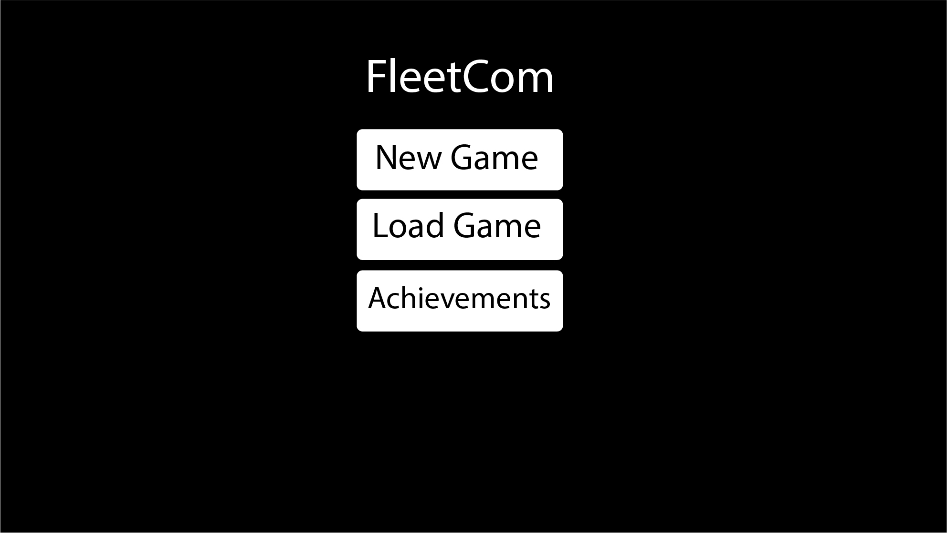

Achievements

Base Review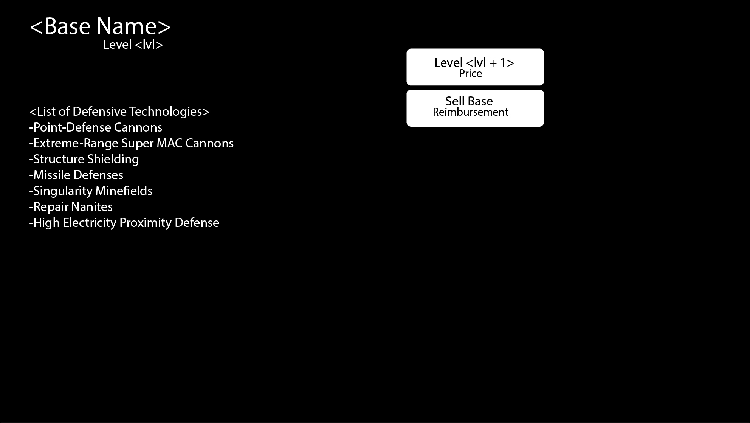

Incursion Map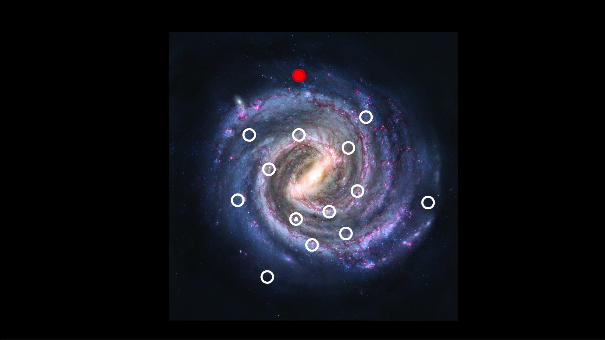

Star Cluster Map

Base Configuration Screen

Research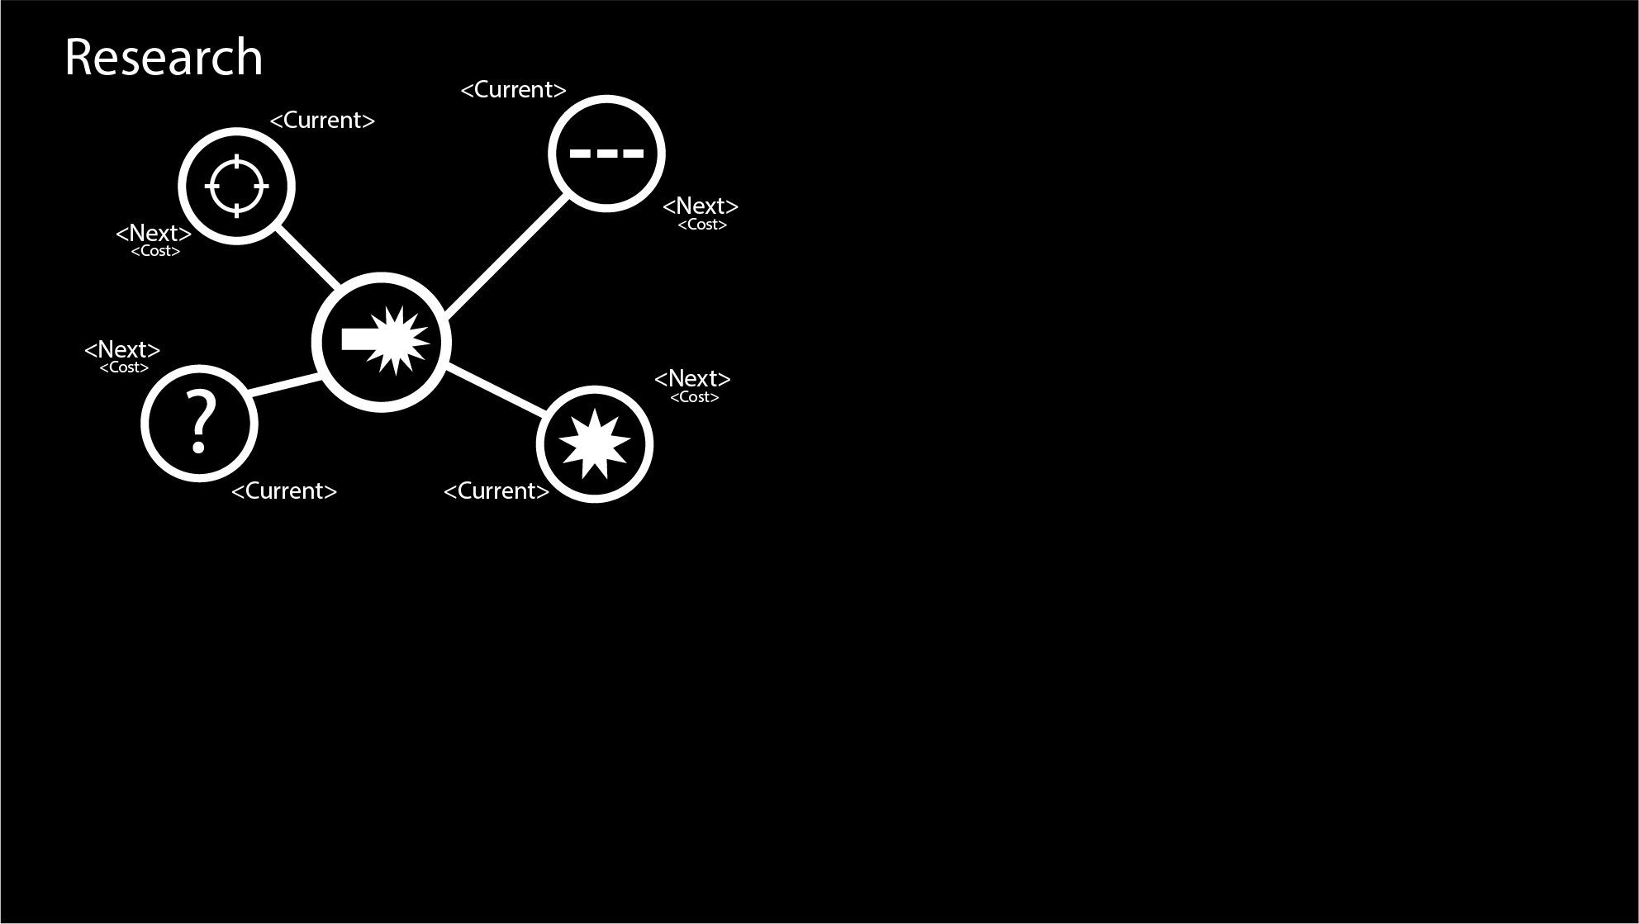

### In Game

### Pause

### Debriefing

### Game Over